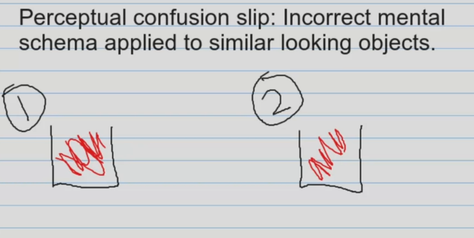

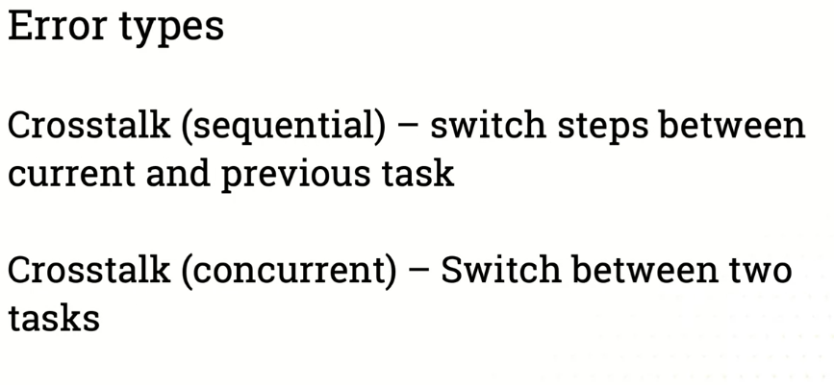

Achieve the goal but something gone wrong after that.

